# I3 Team Report - Sprint 3

## Reflection

| Project Status |
| --- |

For the third sprint of the semester, it has started off slowly due to the team members taking time off the project and having a short break on the study break week. We have completed the frontend setup of Current Assessment, Settings and Password Reset pages for both Student and UC Clients, as well as connecting the current assessment and dashboard pages to the backend data. On the backend we have added Selenium End-to-end Testing to test the added APIs linked to the frontend pages.

Plan for Next Sprint

* Sprucing up the UIs for both clients, making them much more user friendly and engaging to use.
* Finishing the remaining cards from this sprint.
* Adding extensions to the application. (Halt Session functionality on the UC client Active Assessment page, diagram of all active computers on the UC client Ongoing Assessment page)
* Sorting out security setups with Curtin University IT staff.
* Thorough application testing through virtual machines on the lab machines.

## Burndown Charts

Below are 2 burndown charts. The first one is based on time completed/remaining (based on estimations from planning poker) and the second one is based on the number of tasks completed.

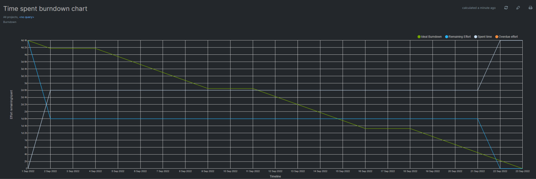

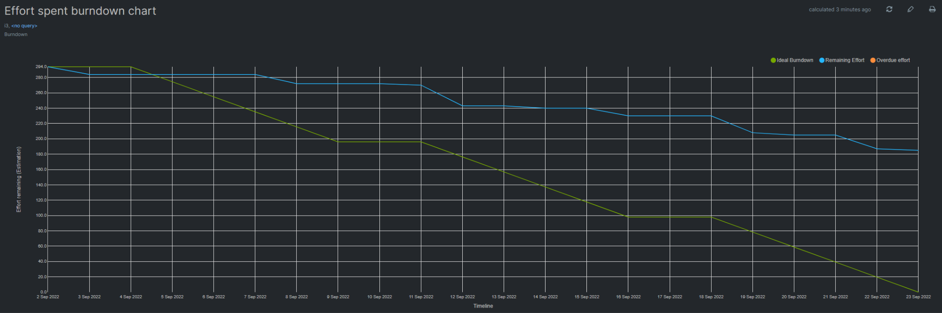

## Toggl Report

## Below is a report generated from Toggl for the last 3 weeks.

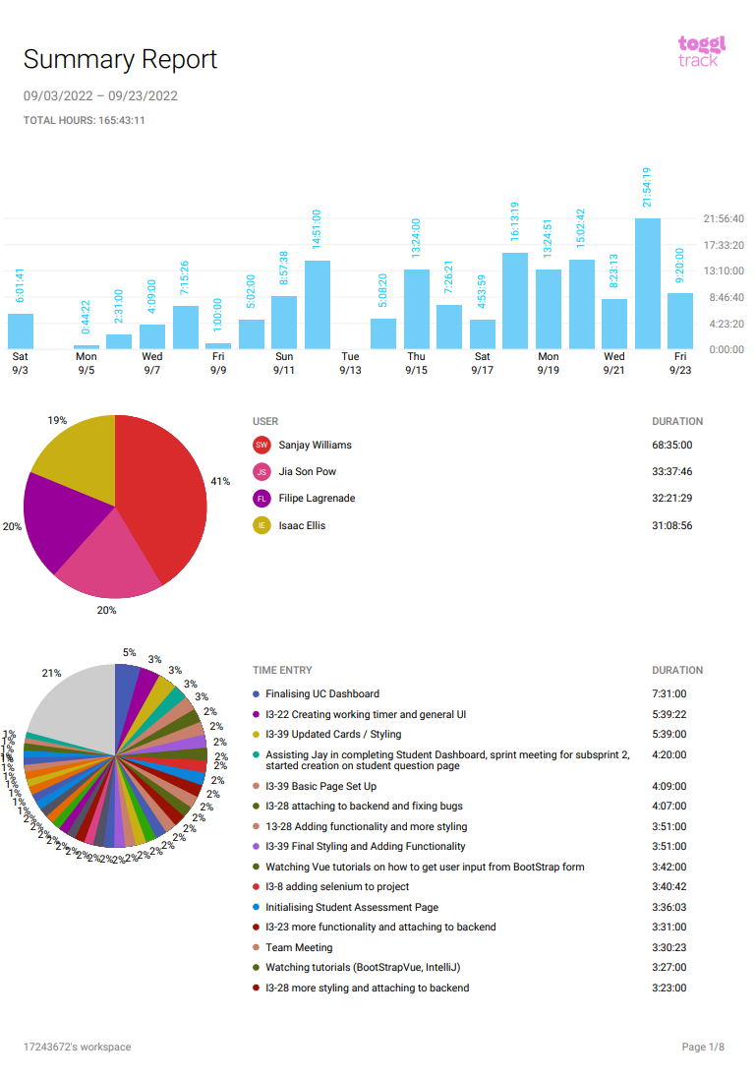

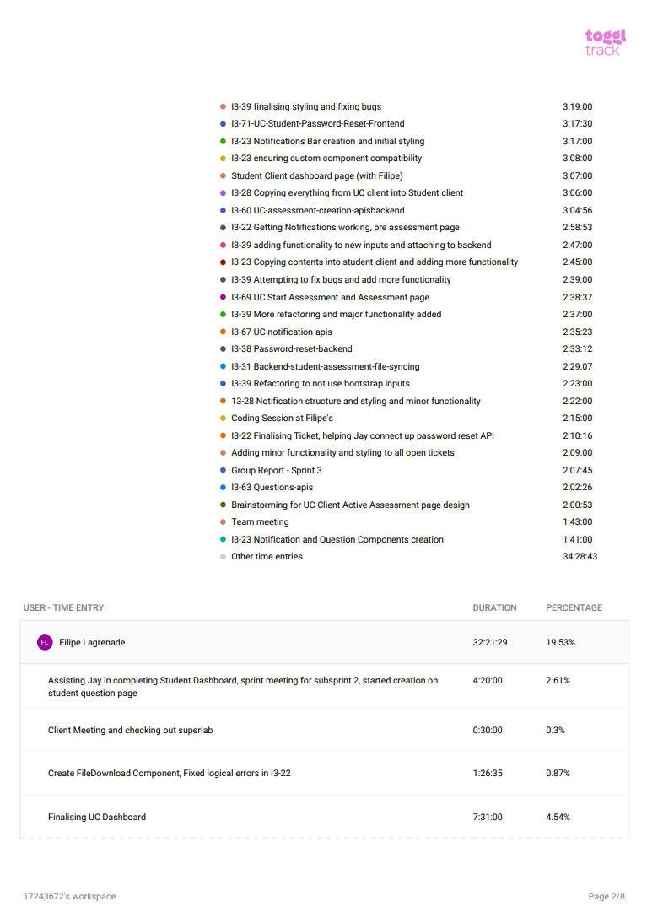

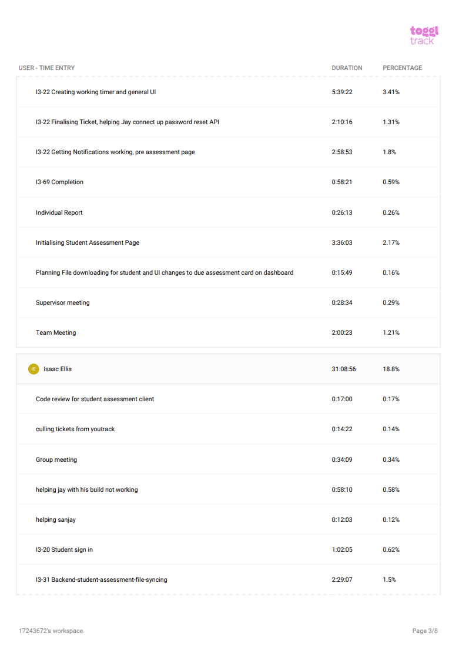

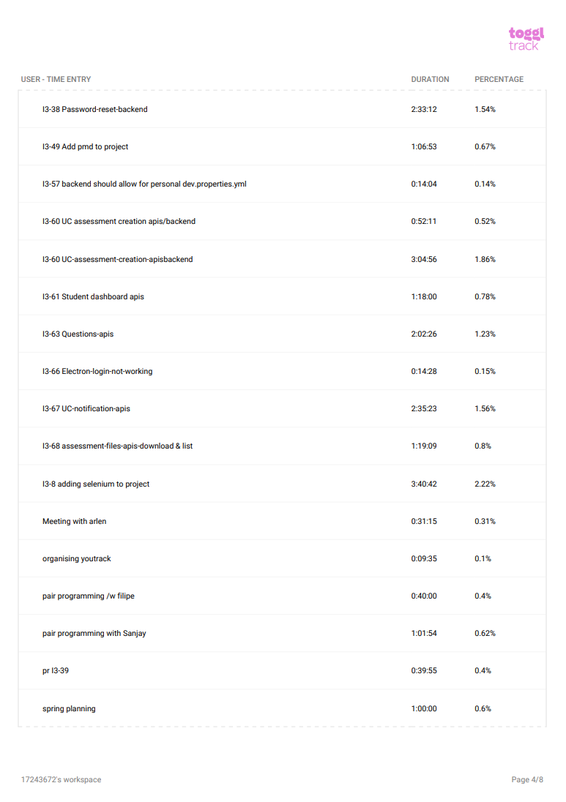

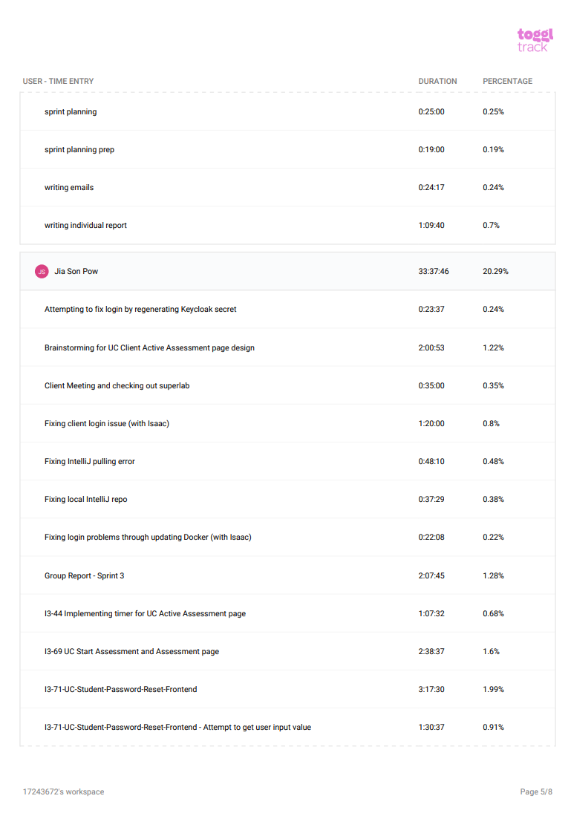

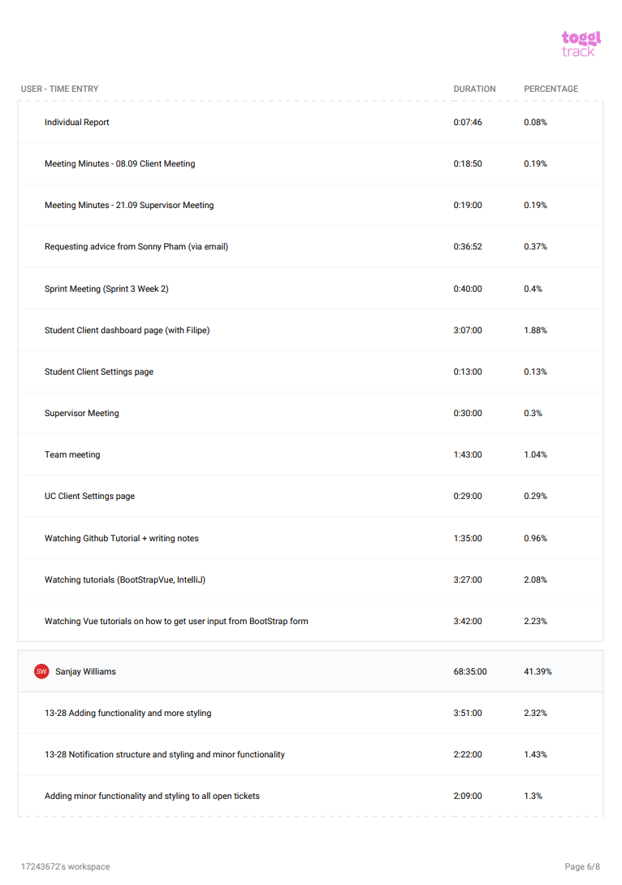

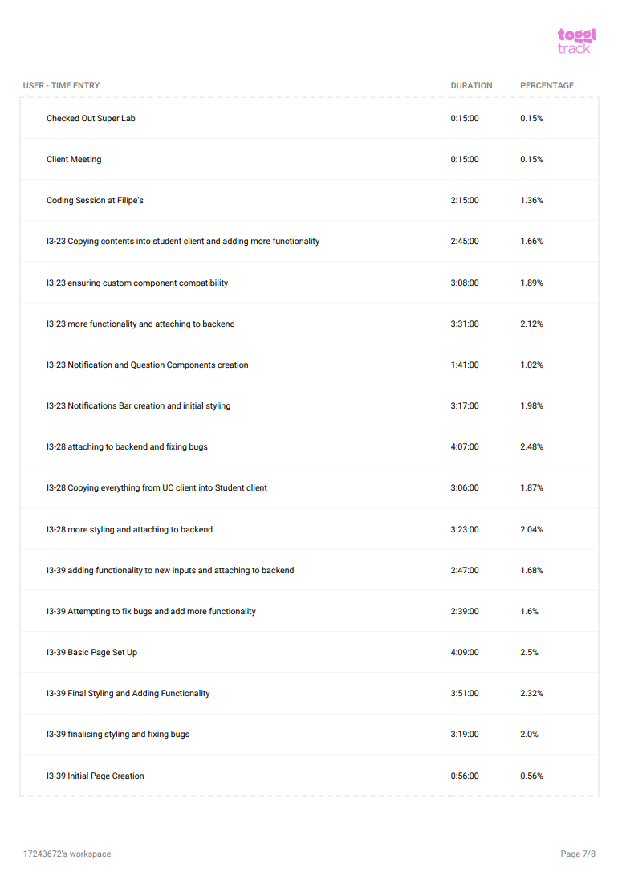

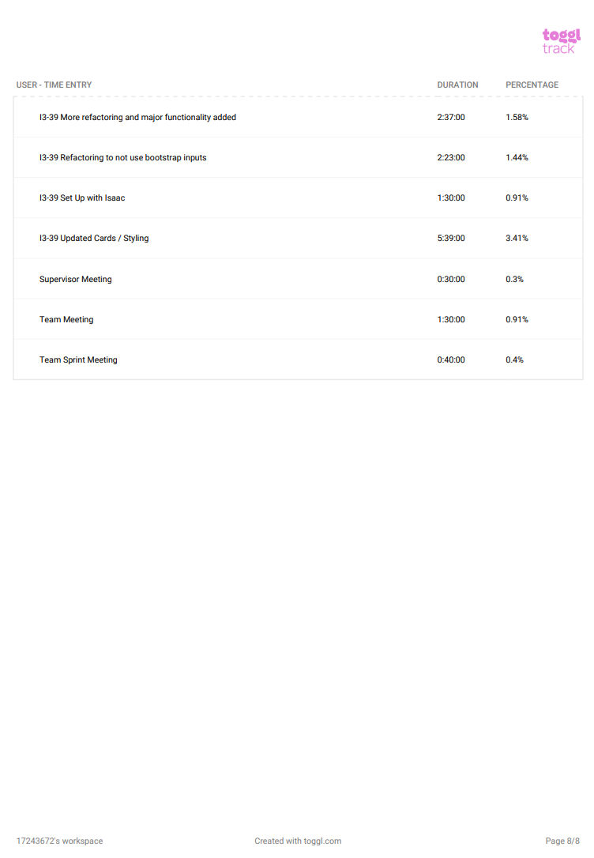

## Tickets completed

| Not Started | In Progress | Completed |
| --- | --- | --- |
| RSync frontend | Student Assessment File-sync backend | Add selenium to backend |
| UC/Admin to View/Edit upcoming assessment | Questions frontend for UC + Student clients | Student sign-in |
| Edit Assessment Update API | UC notifications frontend | Add PMD to project |
|  | UC Assessment Creation frontend | Student Dashboard APIs |
|  | UC/Student Password Reset frontend | UC Client dashboard |
|  | Sprint 3 Report and Agile Work | Student Client dashboard |
|  | Student/UC Settings Frontend | Backend should allow for personal dev.properties.yml |
|  |  | UC assessment creation APIs/backend |
|  |  | Questions APIs |
|  |  | Electron login fixing |
|  |  | Assessment files APIs |
|  |  | Student Start Assessment and Assessment Page |
|  |  | UC Start Assessment and Assessment Page |
|  |  | Password Reset backend |
|  |  | UC Notifications APIS |
|  |  | Questions APIs |
|  |  | Assessment Files Apis |

## Attribution of Work

| Ticket | Team Member |
| --- | --- |
| Add selenium to backend | Isaac Ellis |
| Student sign-in | Isaac Ellis |
| Add PMD to project | Isaac Ellis |
| Student Dashboard APIs | Isaac Ellis |
| UC Client dashboard | Filipe Lagrenade |
| Student Client dashboard | Jia Son Pow, Filipe Lagrenade |
| Backend should allow for personal dev.properties.yml | Isaac Ellis |
| UC assessment creation APIs/backend | Isaac Ellis |
| Electron login fixing | Isaac Ellis |
| Assessment files APIs | Isaac Ellis |
| Student Start Assessment and Assessment Page | Filipe Lagrenade |
| UC Start Assessment and Assessment Page | Filipe Lagrenade |
| Password Reset backend | Isaac Ellis |
| Student Assessment File-sync backend | Isaac Ellis, Filipe Lagrenade |
| Questions frontend for UC + Student clients | Sanjay Williams |
| UC notifications frontend | Sanjay Williams |
| UC Assessment Creation frontend | Sanjay Williams |
| UC/Student Password Reset frontend | Jia Son Pow |
| RSync frontend | Filipe Lagrenade, Isaac Ellis |
| UC/Admin to View/Edit upcoming assessment | Isaac Ellis, Sanjay Williams |
| Edit Assessment Update API | Isaac Ellis |
| Sprint 3 Report and Agile Work | Jia Son Pow |
| UC Notifications APIS | Isaac Ellis |
| Questions APIs | Isaac Ellis |
| Student/UC Settings Frontend | Jia Son Pow |

## Repository

Below is a link to the bitbucket repository.

<https://bitbucket.org/isaacellis1/i3-super-lab/src/master/>

## Meeting Minutes

